Expression of Interest (EOI) Form
CREATE Voices in Action conference – held online from 26 – 29 April 2022
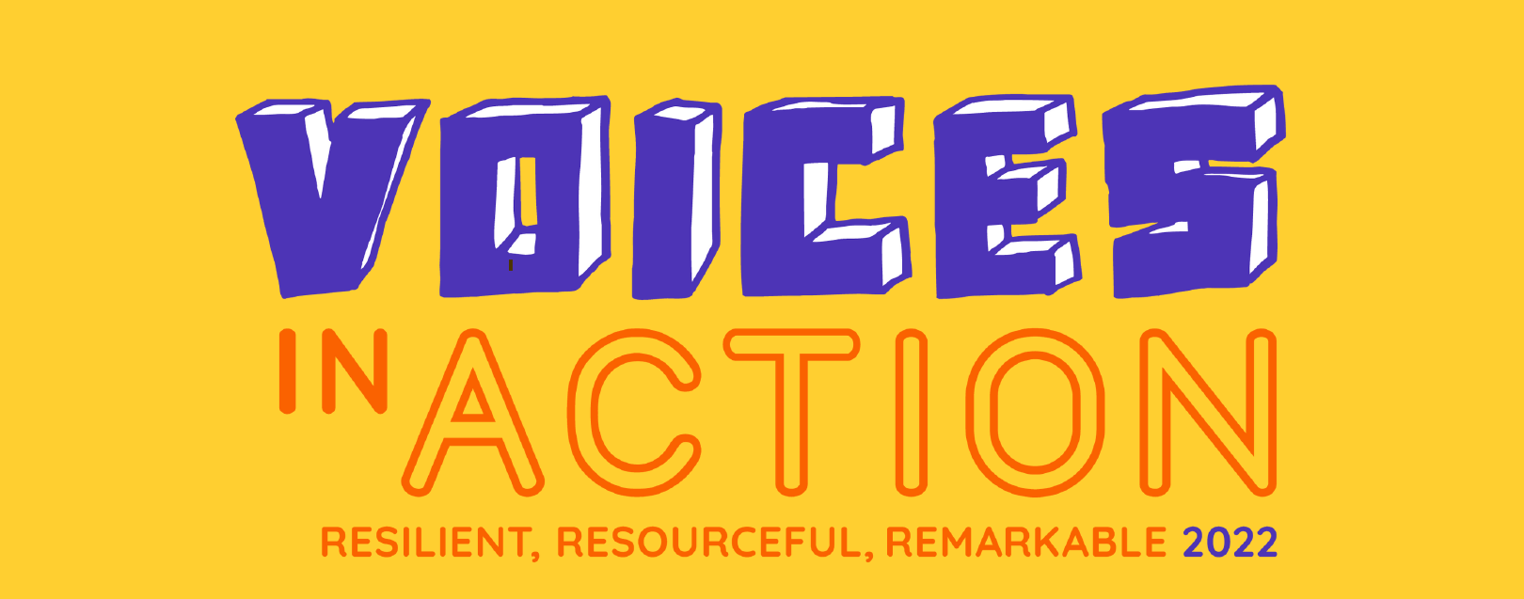
If you are interested in attending the CREATE Voices in Action conference, please complete this EOI form and return it to the Department for Child Protection at Isabella.ciezkowski@sa.gov.au by Monday 21 March March 2022. Successful applicants will be notified by Wednesday 23 March 2022 with further advice on how to register.
Your contact details:
Your full name:
Your email address:
Your phone number:

Select ticket type and number of tickets
Young person (12 – 25 years)
Carer
DCP worker
Please provide the DCP office you or the young person are case managed by:
Please provide the name(s) of any other people you are applying for

Please email this completed form to Isabella.ciezkowski@sa.gov.au by Monday 21 March 2022. Successful applicants will be notified by Friday 25 March 2022 with further advice on how to register.

